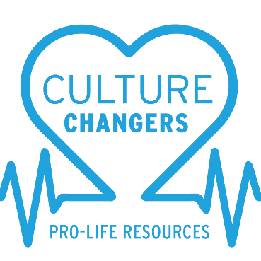

“FIGHT FOR LIFE” – Participant Workbook

Video 1 – The Sanctity of Human Life
- Before watching the video, when did you believe life began?

- What did you learn about what the Bible says about life?

- What does it mean to be created in the image of God?

- What was the most interesting thing you learned about human development in the womb?

- How does the Biblical and medical information in the video impact your views
about life in the womb?

- Knowing every person is created in the image of God and has value, how does
this affect the way you view yourself and others?

Video 2 – The Truth About Abortion
- Before watching the video, what was your view on abortion?

- How has your understanding changed about what an abortion involves?

- Does abortion end life? How does culture’s message compare with what you
learned?

- As Christians, who do we believe has the authority to end a life?

- The Bible does not use the word “abortion.” What does the Bible say about ending
a life?

Video 3 – Culture Changers
- As you heard, “You cannot be neutral, you must not be silent.” How should
Christians respond to abortion?

- How does God’s Word tell us to defend and protect life?

- How would you respond if a friend told you she was pregnant and thinking about
abortion?

- How can you be a Culture Changer in your school, home or church?

- Are there any topics you feel nervous about facing as you try to be a Culture
Changer?

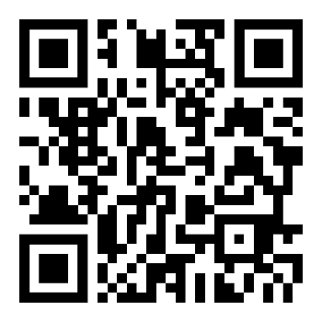  Use this link to access these videos and  workbook to lead another group through  this series.  You’ll also find other helpful prolife links  on this page. | 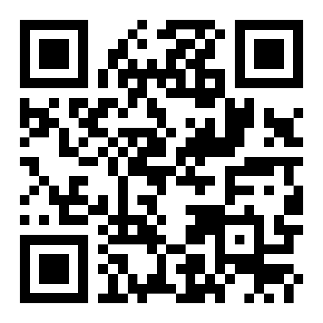  Use this link to let us know if this video series  was beneficial and how we can improve.


If you have experienced an abortion, God’s desire is for you to accept His forgiveness and receive healing. Use this link for information on confidential, small group classes.

